Baseline int8 Quantized Model
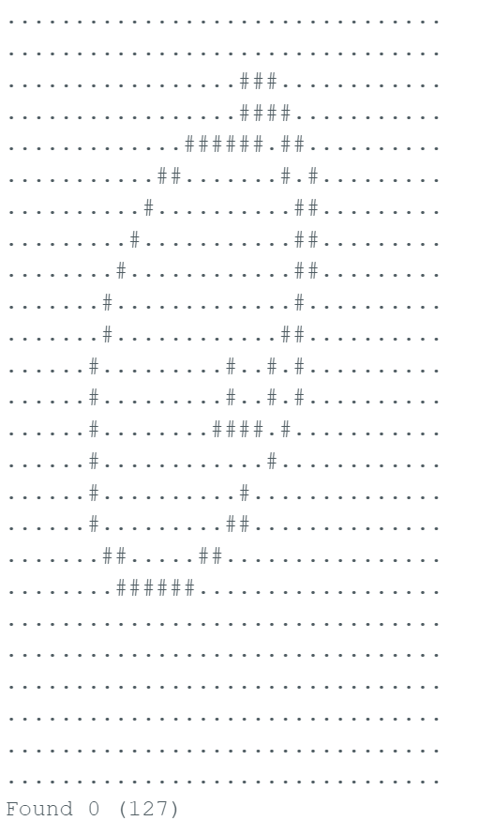
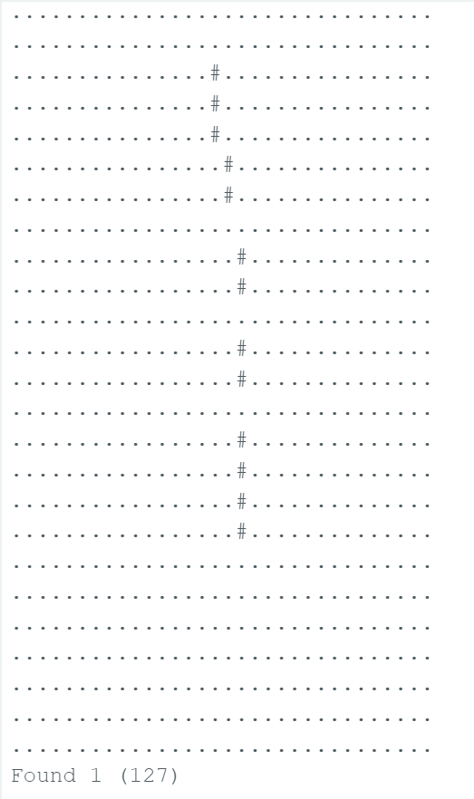
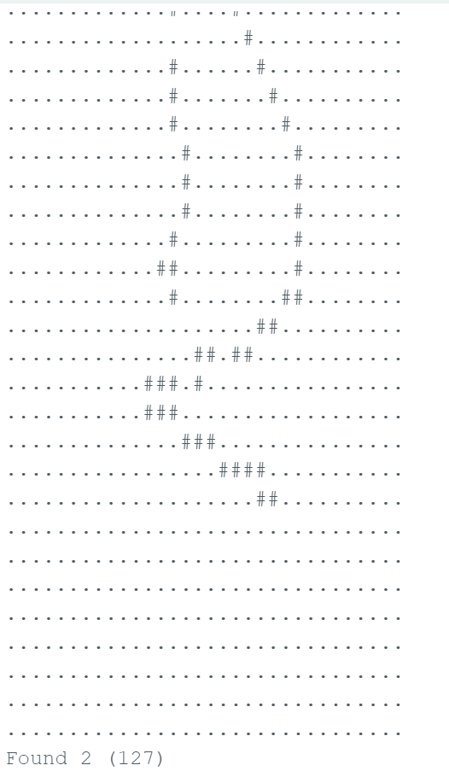
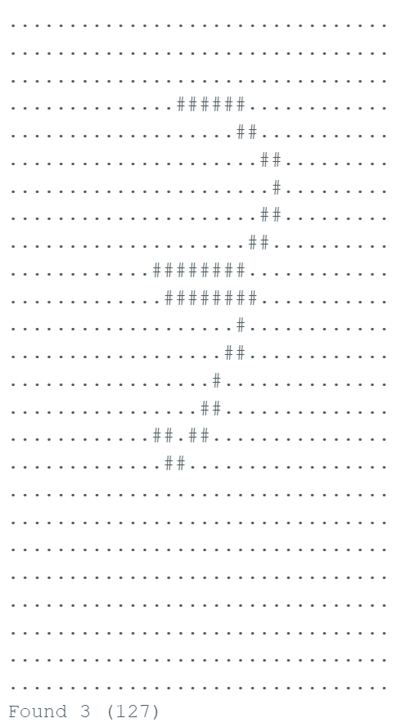
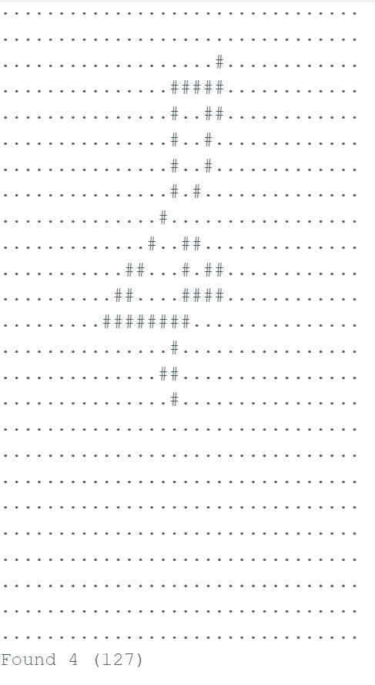
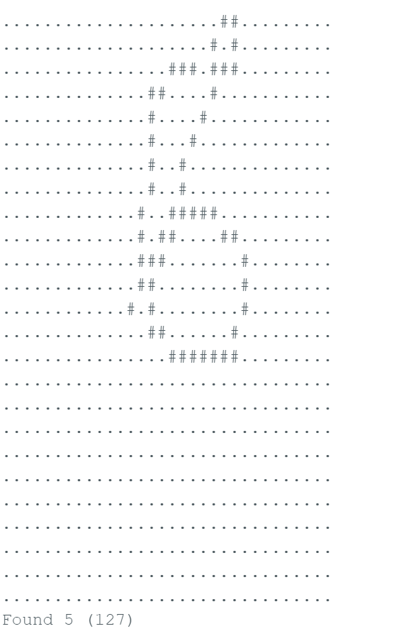
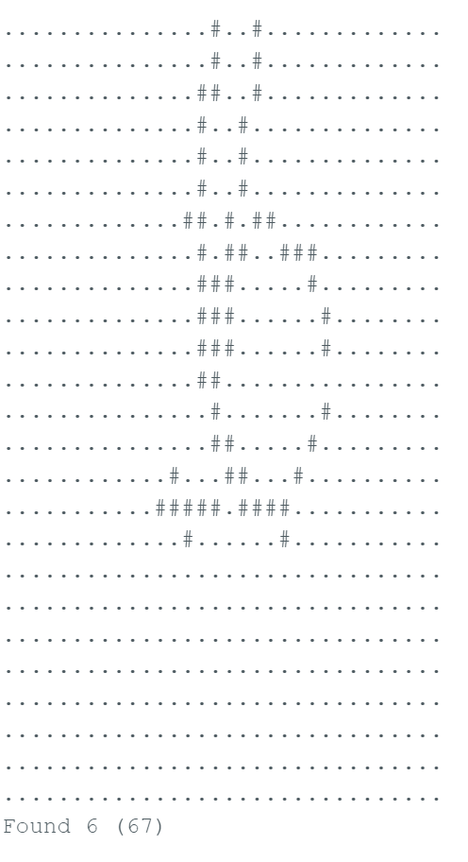
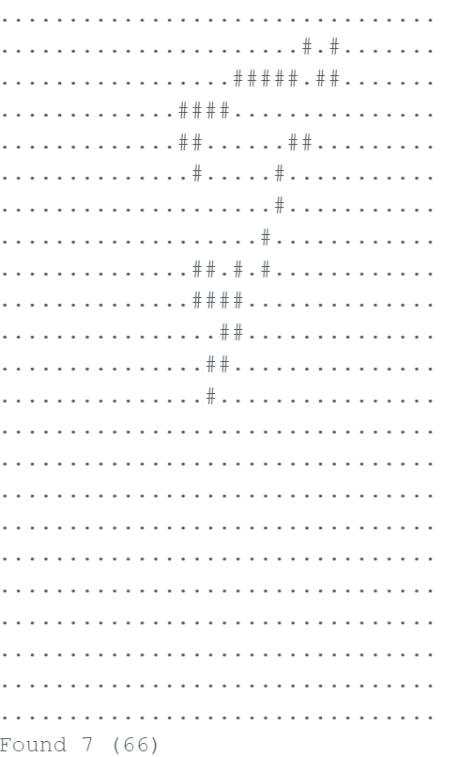
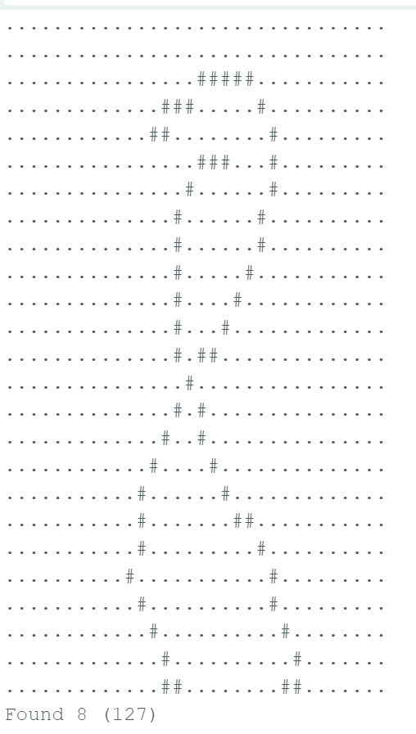
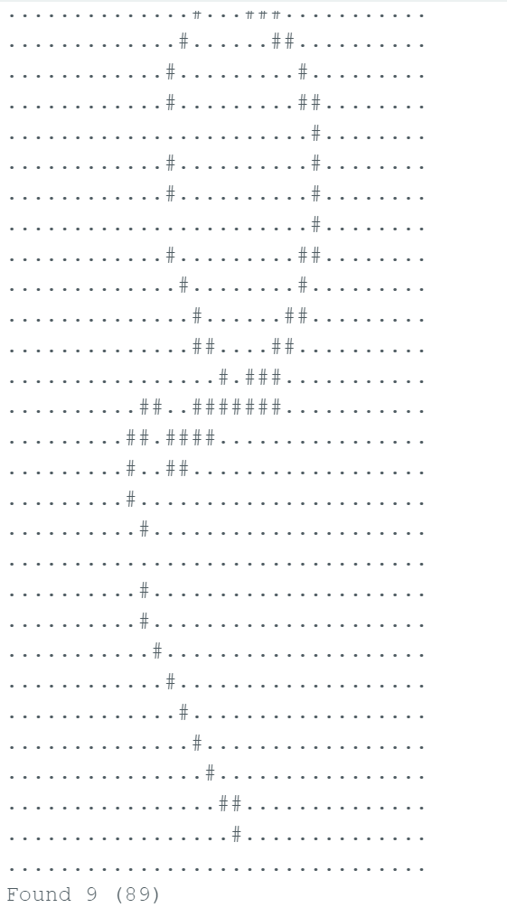

Fine-Tuned int8 Quantized Model
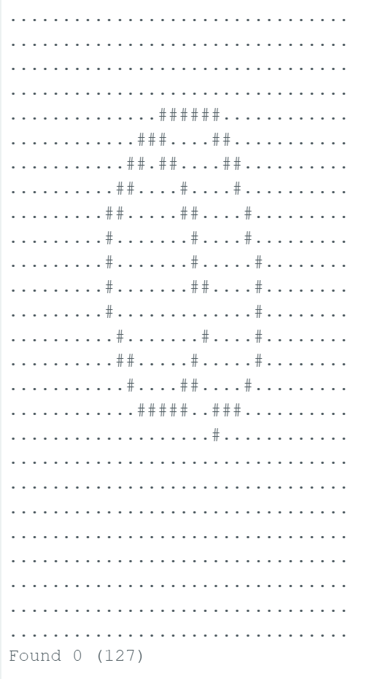
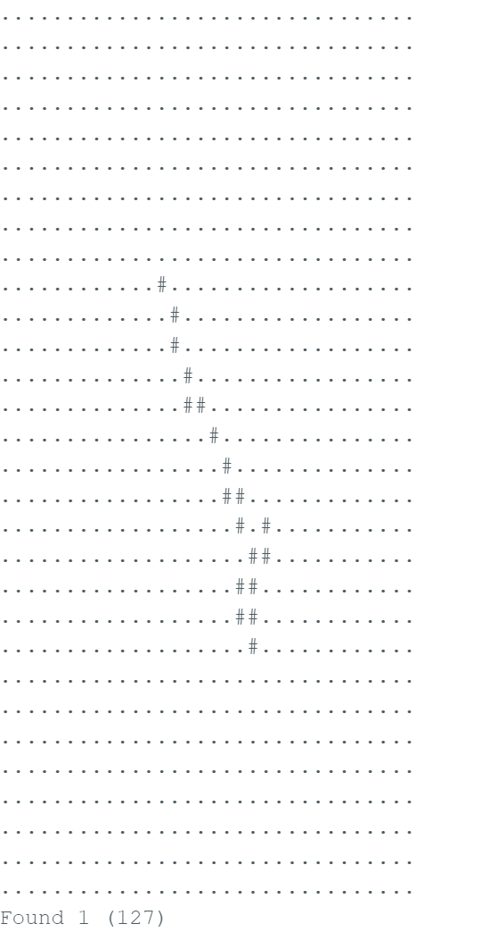
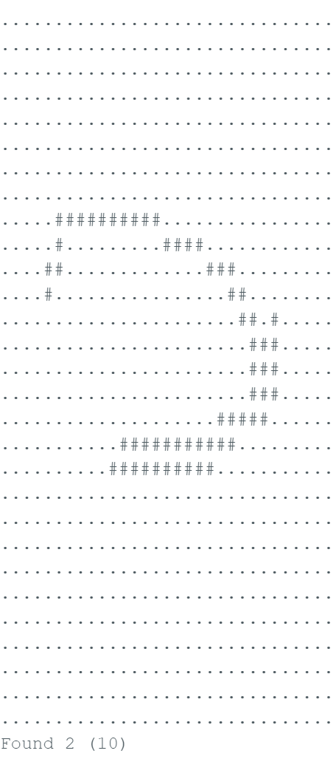
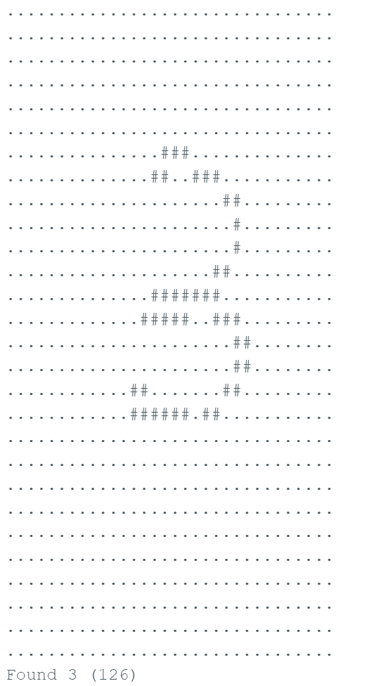
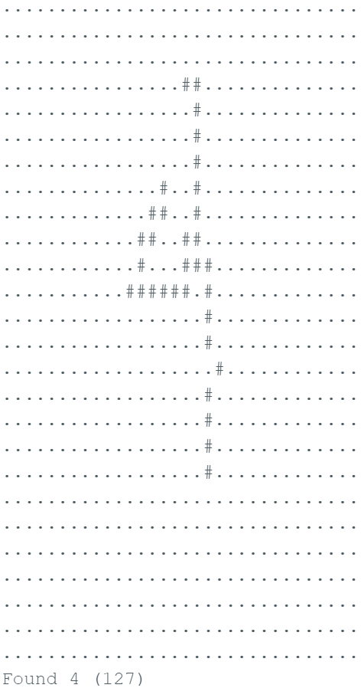
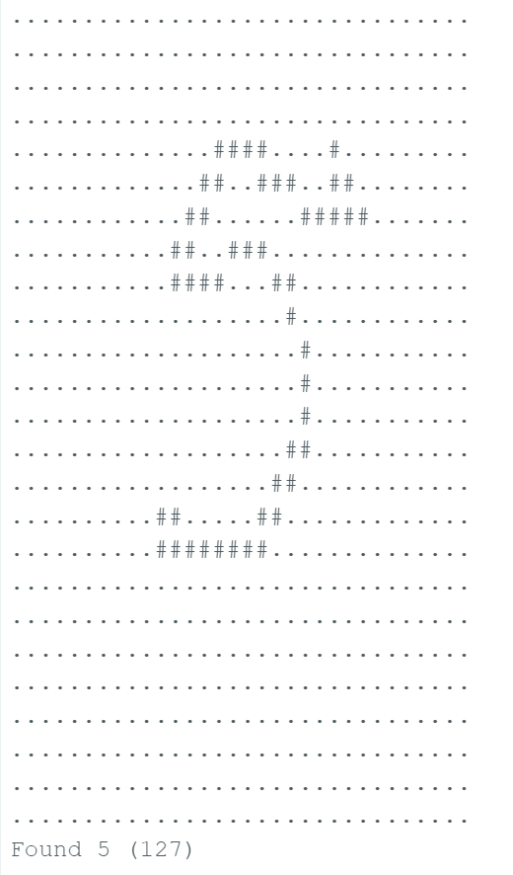
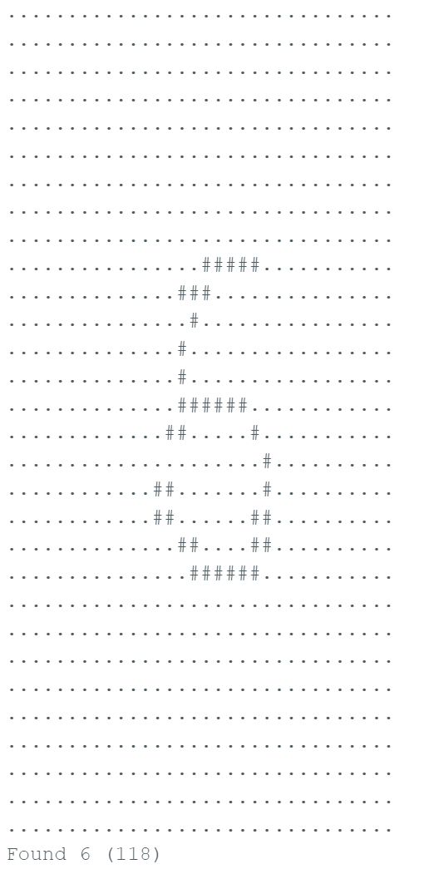

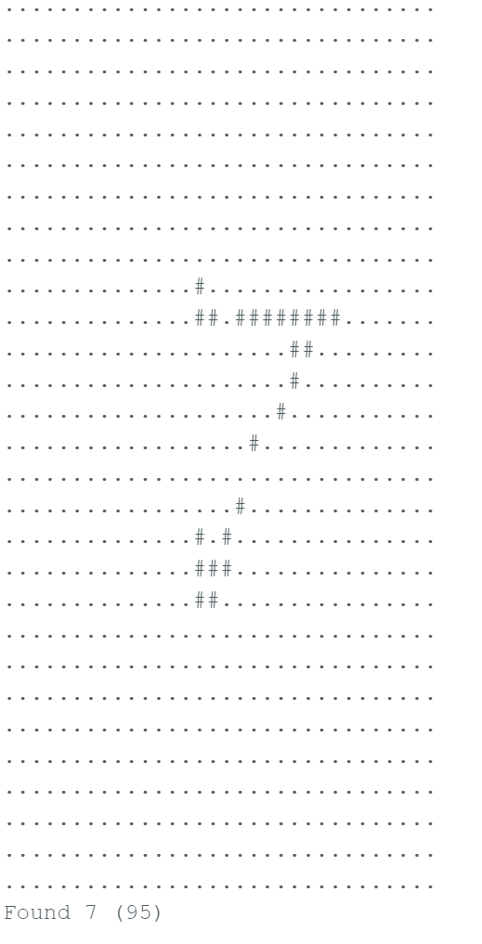
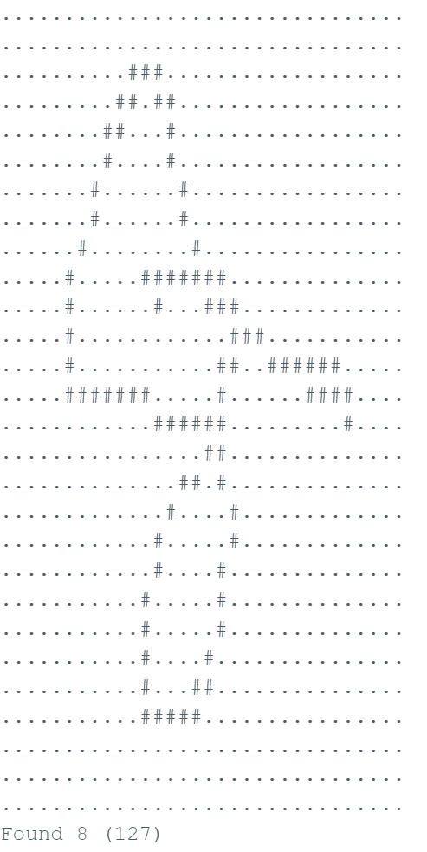
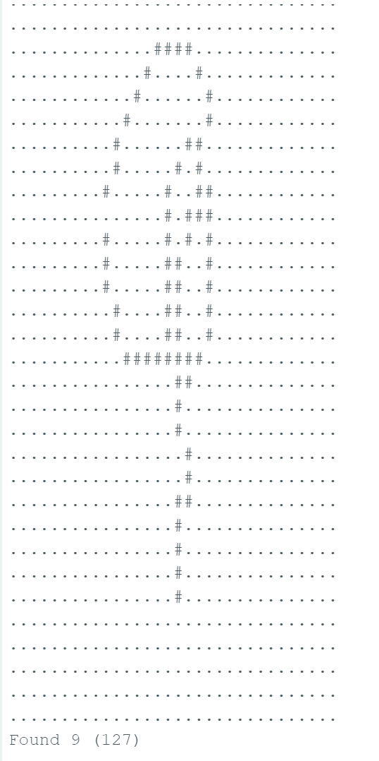

Task 4: Compare Results and Reflect
The baseline int8 quantized model performed very well on the original dataset, achieving 97.8% accuracy with only 12 unknown predictions. When testing the model on my own gestures using the Arduino Nano 33 BLE Sense, some digits were recognized more reliably than others. Digits like 8 and 9 were generally easier for the model to classify correctly, while digits such as 4, 5, and 6 were more difficult because their motion patterns were more similar and inconsistent. After collecting my own gesture data and fine-tuning the model, the personalized evaluation accuracy improved from 46% to 77%. Fine-tuning helped the model adapt somewhat to my gesture style, but the improvement was limited because my collected dataset was relatively small. Since there were only a limited number of training samples per digit, the model still struggled to consistently distinguish some gestures, especially for digits with similar stroke patterns. Overall, the fine-tuned model showed some improvement for my personal gestures, but the baseline model was still competitive because the personalized dataset was too small for strong generalization. Increasing the number of collected gesture samples and adding more augmentation would likely improve the fine-tuned model further.

